|  |  |
| --- | --- |
| File:COMSATS new logo.jpg - Wikimedia Commons  Lab Assignment - 03 | **submitted by:**  **Shahzaneer Ahmed**  (Sp21-BCS-087)  **submitted to:**  **Mr. Rizwan Rashid**  **date of submission:**  **December 19th, 2021** |

Question 1

# Source Code

*//------------------------------------------------------------------  
//--------------------SHAHZANEER AHMED------------------------------  
//-----------------------SP21-BCS-087-------------------------------  
//--------------------------lAB-03----------------------------------  
//-----------------------Question 1---------------------------------  
//------------------------------------------------------------------  
  
//Question – 1: ______  
// Write a Menu Driven JAVA program that creates a string array by taking input from user and  
// perform following tasks by displaying menu to user, the menu operations are implemented using  
// methods:  
// a) Calculate length of string.  
// b) Count number of words in string.  
// c) Check a string is palindrome or not.  
// d) Find a word within the String. If found display its starting position.  
// e) Convert a string in lowercase.  
// f) Convert a string in uppercase  
  
import java.util.Scanner*;  
*public class Question1* {  
 *public static void* main(*String*[] *args*) {  
 *Scanner* input = *new* Scanner(*System*.in);  
 *System*.out.println("Enter a String :");  
 *String* str = input.nextLine();  
  
 *while*(*true*) {  
 *System*.out.println("Enter what operation do you want to perform on the string :");  
 *System*.out.println("""  
 1. length of String  
 2. no of words in String  
 3. check if palindrome or not.  
 4. find a word with in String.  
 5. lowercase  
 6. uppercase  
 7. exit  
 """);  
  
  
 *int* option = input.nextInt();  
  
 *if* (option == 7) *System*.*exit*(0);  
  
 *switch* (option) {  
 *case* 1 -> *System*.out.println(*lengthOfString*(str));  
 *case* 2 -> *System*.out.println(*noOfWords*(str));  
 *case* 3 -> *System*.out.println(*isPalindrome*(str));  
 *case* 4 -> {  
 *if* (*findWord*(str)==-1) *System*.out.println("Your word doesn't exist");  
 *else System*.out.println(*findWord*(str));  
 }  
 *case* 5 -> *System*.out.println(*lowerCase*(str));  
 *case* 6 -> *System*.out.println(*upperCase*(str));  
 *default* -> *System*.out.println("Enter correct option please ");  
 }  
 }  
  
 }  
  
 *static String* upperCase(*String str*) {  
 *return str*.toUpperCase();  
  
 }  
  
 *static String* lowerCase(*String str*){  
  
 *return str*.toLowerCase();  
 }  
  
 *static int* findWord(*String str*) {  
 *Scanner* findvar = *new* Scanner(*System*.in);  
 *System*.out.println("Enter the word you want to find :");  
 *String* word = findvar.next();  
 *int* index = *str*.indexOf(word);  
 *return* index;  
  
 }  
  
 *static boolean* isPalindrome(*String str*) {  
 *String* s = "";  
 *for* (*int* i = *str*.length()-1; i>=0;i--){  
 s+=*str*.charAt(i);  
 }  
 *if* (s.equals(*str*)) *return true*;  
 *else return false*;  
 }  
  
 *static int* noOfWords(*String str*) {  
 *String* [] arr = *str*.split(" ");  
 *int* noOfWords = arr.length;  
 *return* noOfWords;  
 }  
  
 *static int* lengthOfString(*String str*) {  
  
 *return str*.length();  
 }  
  
}

# Output

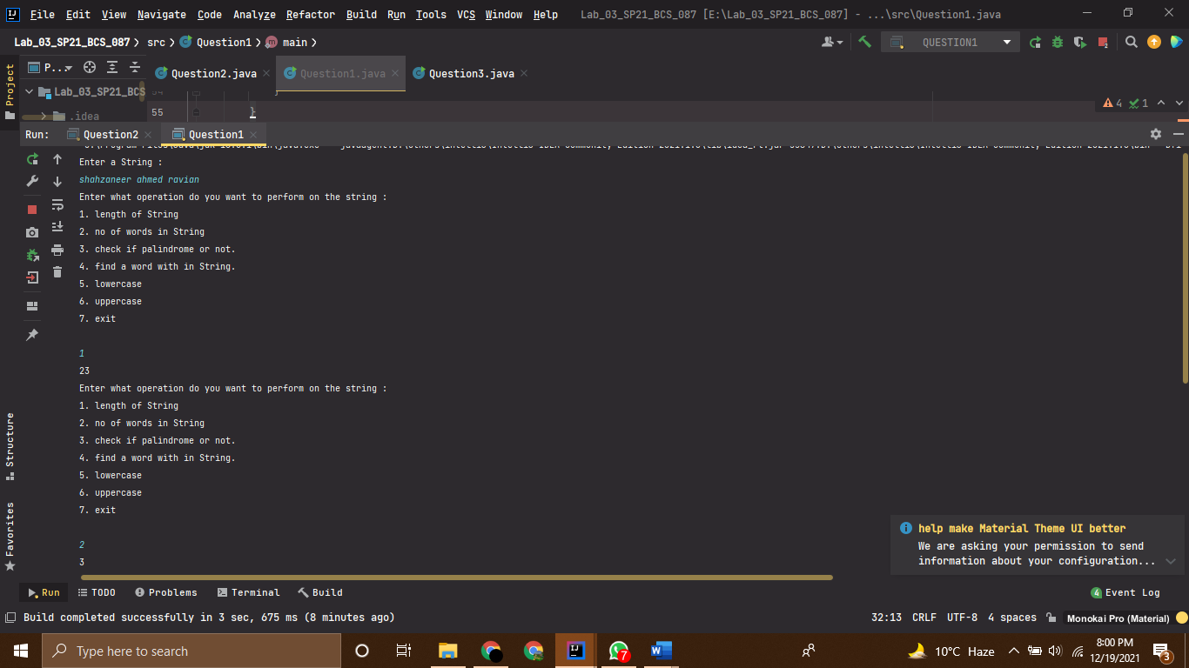

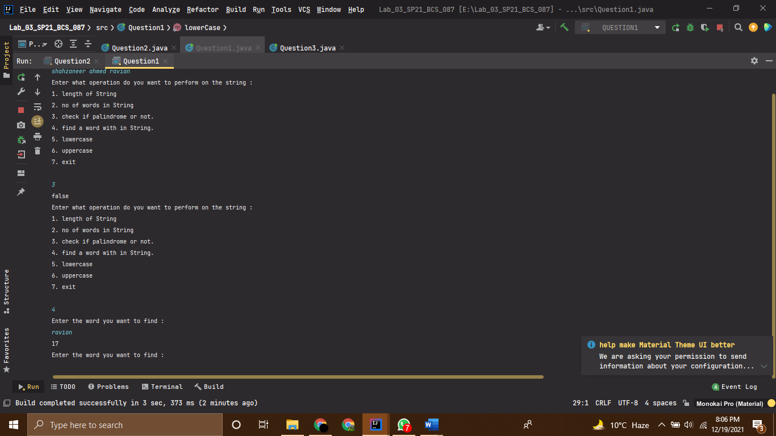

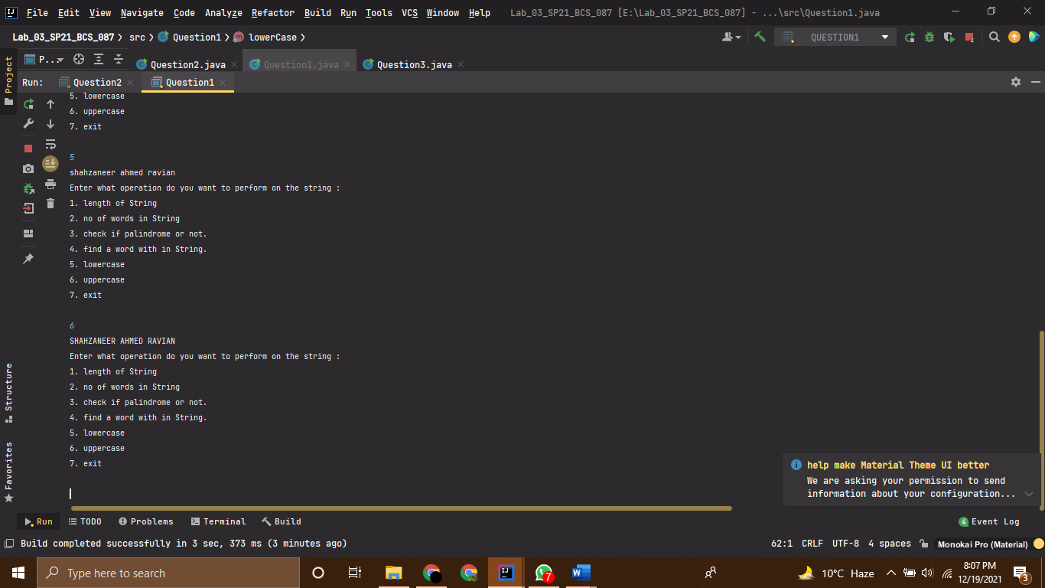

Question 2

# Source Code

*//------------------------------------------------------------------  
//--------------------SHAHZANEER AHMED------------------------------  
//-----------------------SP21-BCS-087-------------------------------  
//--------------------------lAB-03----------------------------------  
//-----------------------Question 2---------------------------------  
//------------------------------------------------------------------  
  
//Write a Menu Driven JAVA program that creates a two-dimensional array/Matrix of size n X m  
// where n represent the students and m represent the subjects and initialize it with user. The  
// program should do following Tasks using Menu, the menu operations are implemented using  
// methods:  
// a) Total_Marks: Calculates total/sum of the values in the specified row (student).  
// b) Avg_Subject: Calculates Average of the values in the specified column (subject).  
// c) Stud_Highest: Finds highest value in the specified row of the array and return  
// that subject name.  
// d) Stud_Lowest: Finds lowest value in the specified row of the array and return that  
// subject name.  
  
import java.util.Scanner*;  
*public class Question2* {  
 *public static void* main(*String*[] *args*) {  
  
 *Scanner* input = *new* Scanner(*System*.in);  
 *System*.out.println("Enter the no of Students :");  
 *int* noStudents = input.nextInt();  
 *System*.out.println("Enter the no of Subjects :");  
 *int* noSubjects = input.nextInt();  
  
 *String* [][] studentsWithSubjects = *new* String[noStudents][noSubjects+1];  
 *int* [][] rollNoWithMarks = *new int*[noStudents][noSubjects+1];  
  
 *inputDetails*(studentsWithSubjects);  
 *allotRollNumbers*(rollNoWithMarks);  
 *subjectsMarksInput*(noSubjects,rollNoWithMarks);  
  
  
 *while*(*true*){  
 *System*.out.println("Enter the corresponding number to select an option :");  
 *System*.out.println("""  
 1. Total Marks of a Student.  
 2. Average Marks of a subject.  
 3. Name of Subject in which a Student got highest marks.  
 4. Name of Subject in which a Student got lowest marks.  
 5. exit  
 """);  
 *int* selection = input.nextInt();  
  
 *if* (selection==5) *System*.*exit*(0);  
  
 *switch* (selection){  
 *case* 1 -> *totalMarks*(rollNoWithMarks,noSubjects,noStudents);  
 *case* 2 -> *averageSubjects*(rollNoWithMarks,noSubjects,noStudents);  
 *case* 3 -> *highestMarks*(studentsWithSubjects,rollNoWithMarks,noSubjects);  
 *case* 4 -> *lowestMarks*(studentsWithSubjects,rollNoWithMarks,noSubjects);  
 }  
 }  
  
 }  
  
  
  
  
 *static void* inputDetails(*String* [][] *studentsWithSubjects*){  
 *Scanner* input = *new* Scanner(*System*.in);  
 *System*.out.println("Enter the student name with his subjects separated by space");  
 *for*(*int* i = 0; i<*studentsWithSubjects*.length;i++){  
 *for*(*int* j = 0; j<*studentsWithSubjects*[i].length;j++){  
  
 *studentsWithSubjects*[i][j] = input.next();  
  
 }  
 }  
  
 }  
 *static void* subjectsMarksInput(*int subjects* , *int* [][]*rollNoWithMarks*){  
 *Scanner* input = *new* Scanner(*System*.in);  
 *for* (*int* k = 1; k<=*subjects*;k++) {  
 *System*.out.printf("Enter marks for subject-%d for each student according to his/her roll-number",k);  
 *for* (*int* i = 0; i < *rollNoWithMarks*.length; i++) {  
 *for* (*int* j = k; j < k+1; j++) {  
 *rollNoWithMarks*[i][j] = input.nextInt();  
 }  
 }  
 }  
  
 *for*(*int* i = 0; i<*rollNoWithMarks*.length;i++){  
 *for*(*int* j = 0; j<*rollNoWithMarks*[i].length;j++){  
 *System*.out.print(*rollNoWithMarks*[i][j]+" ");  
  
 }  
 *System*.out.println();  
 }  
  
 }  
 *static void* allotRollNumbers (*int* [][] *rollNoWithMarks*){  
 *//Assigning roll_Numbers  
 for* (*int* i = 0; i<*rollNoWithMarks*.length;i++){  
 *for* (*int* j =0 ;j<1; j++){  
 *rollNoWithMarks*[i][j] = i+1;  
 }  
  
 }  
 *System*.out.println("You Roll numbers are as :");  
 *for*(*int* i = 0; i<*rollNoWithMarks*.length;i++){  
 *for*(*int* j = 0; j<*rollNoWithMarks*[i].length;j++){  
 *System*.out.print(*rollNoWithMarks*[i][j]+" ");  
  
 }  
 *System*.out.println();  
 }  
 }  
 *static void* totalMarks (*int* [][] *rollNoWithMarks*, *int subjects*,*int students*){  
 *Scanner* input = *new* Scanner(*System*.in);  
 *System*.out.println("Enter the roll number whose total marks you want to calculate :");  
 *int* rollNumber = input.nextInt();  
  
 *if* (rollNumber<=*students*) {  
 *int* totalMarks = 0;  
  
 *for* (*int* i = rollNumber - 1; i < rollNumber; i++) {  
 *for* (*int* j = 1; j < *subjects* + 1; j++) {  
 totalMarks += *rollNoWithMarks*[i][j];  
 }  
 }  
  
 *System*.out.printf("The total marks of Roll number %d are : %d \n", rollNumber, totalMarks);  
 }  
 *else System*.out.println("Please enter valid roll number !");  
 }  
 *static void* averageSubjects (*int*[][] *rollNoWithMarks*,*int subjects*,*int students*){  
 *Scanner* input = *new* Scanner(*System*.in);  
 *System*.out.println("Enter the subject no whose average marks you want to calculate :");  
 *int* subjectNo = input.nextInt();  
  
 *if* (subjectNo <= *subjects*) {  
  
 *int* sum = 0;  
  
 *for* (*int* i = 0; i < *rollNoWithMarks*.length; i++) {  
 *for* (*int* j = subjectNo; j < subjectNo + 1; j++) {  
 sum += *rollNoWithMarks*[i][j];  
 }  
 }  
 *double* average = sum / *students*;  
  
 *System*.out.println("The average is " + average);  
 } *else System*.out.println("Please enter valid subject number !");  
  
 }  
 *static void* highestMarks(*String*[][] *studentsWithSubjects*, *int* [][] *rollNoWithMarks*, *int subjects*){  
 *Scanner* input = *new* Scanner(*System*.in);  
 *System*.out.println("Enter the roll number whose highest marks in a subject you want to know :");  
 *int* rollNumber = input.nextInt();  
  
 *int* highestMarks = 0;  
 *int* rowsIndex = 0,columnIndex = 0;  
 *for*( *int* i = rollNumber-1;i<rollNumber;i++){  
 *for*(*int* j = 1;j<*subjects*+1;j++){  
 *if*(highestMarks<*rollNoWithMarks*[i][j]){  
 highestMarks = *rollNoWithMarks*[i][j];  
 rowsIndex = i;  
 columnIndex = j;  
  
 }  
 }  
 }  
  
 *System*.out.printf("Thus the highest marks are %d and are of %s subject ",highestMarks,  
 *studentsWithSubjects*[rowsIndex][columnIndex]);  
 }  
 *static void* lowestMarks(*String* [][] *studentsWithSubjects*,*int* [][] *rollNoWithMarks*,*int subjects*){  
 *Scanner* input = *new* Scanner(*System*.in);  
 *System*.out.println("Enter the roll number whose lowest marks in a subject you want to know :");  
 *int* rollNumber = input.nextInt();  
 *int* lowestNumbers = 1000000;  
 *int* rowsIndex=0,columnIndex=0;  
 *for*( *int* i = rollNumber-1;i<rollNumber;i++){  
 *for*(*int* j = 1;j<*subjects*+1;j++){  
 *if*(lowestNumbers>*rollNoWithMarks*[i][j]){  
 lowestNumbers = *rollNoWithMarks*[i][j];  
 rowsIndex = i;  
 columnIndex = j;  
 }  
 }  
 }  
 *System*.out.printf("Thus the lowest marks are %d and are of %s subject \n",lowestNumbers,  
 *studentsWithSubjects*[rowsIndex][columnIndex]);  
 }  
  
  
}

# Output

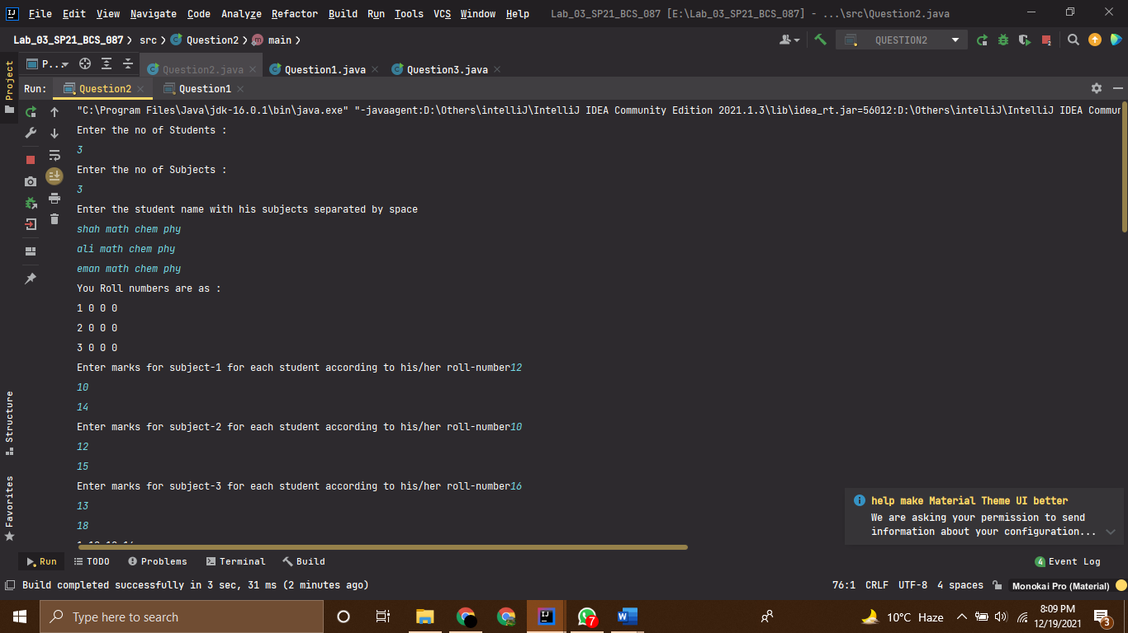

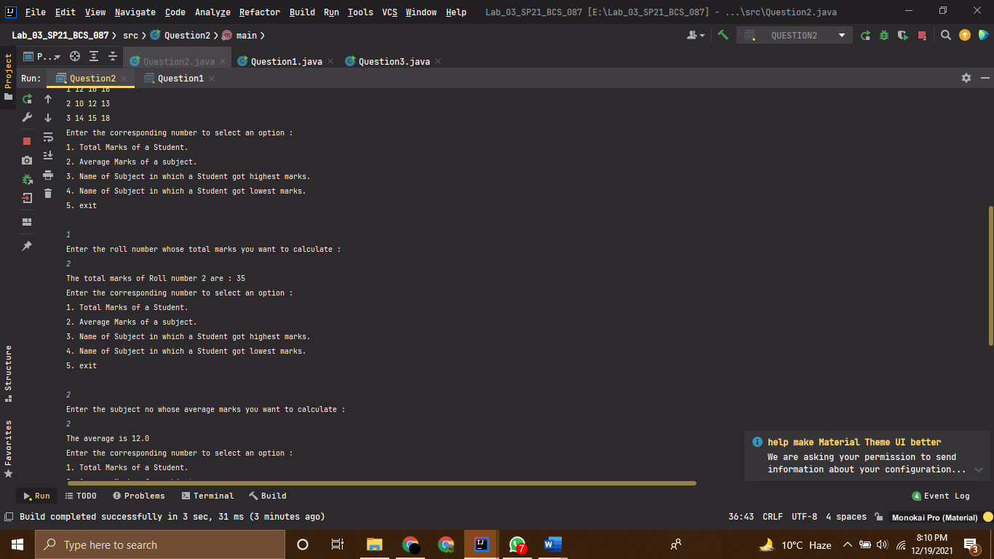

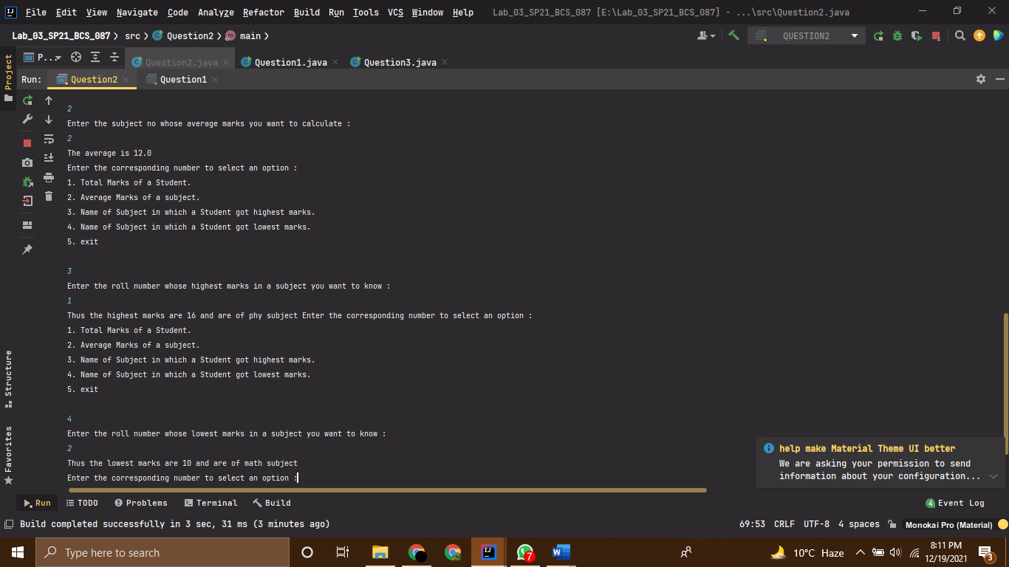

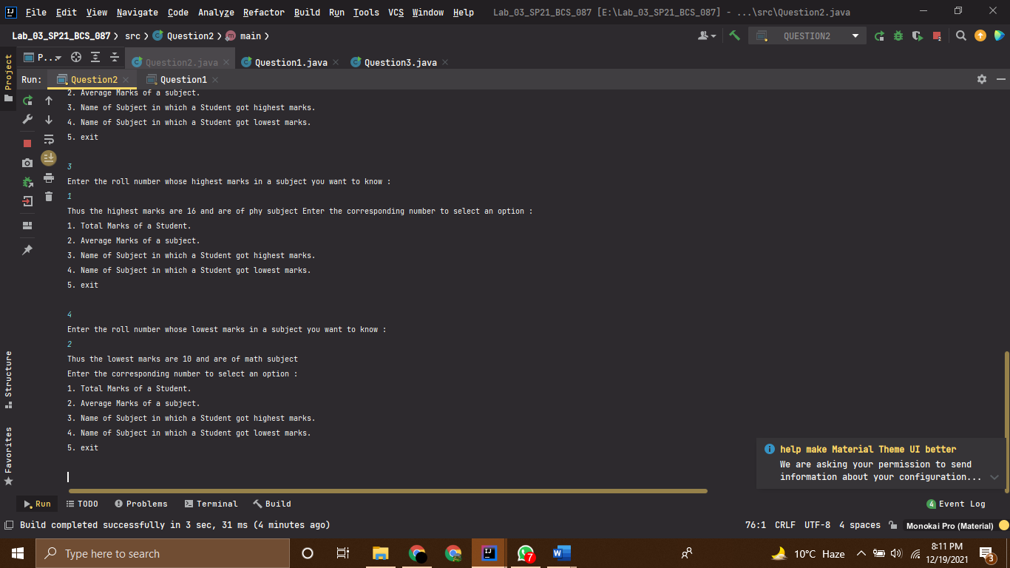

Question 3

# Source Code

*//------------------------------------------------------------------  
//--------------------SHAHZANEER AHMED------------------------------  
//-----------------------SP21-BCS-087-------------------------------  
//--------------------------lAB-03----------------------------------  
//-----------------------Question 3---------------------------------  
//------------------------------------------------------------------  
  
//Question – 3: ______  
// Consider an integer array, the number of elements in which is determined by the user. The  
// elements are also taken as input from the user. Write a program to find those pairs of elements  
// that have the maximum and minimum difference among all element pairs  
  
import java.util.Arrays*;  
*import java.util.Scanner*;  
*public class Question3* {  
 *public static void* main(*String*[] *args*) {  
 *Scanner* input = *new* Scanner(*System*.in);  
 *System*.out.println("Enter the size of array :");  
 *int* size = input.nextInt();  
 *int* [] array = *new int*[size];  
  
 *for*(*int* i = 0; i<array.length;i++){  
 *System*.out.printf("Enter element at index %d :\n",i);  
 array[i] = input.nextInt();  
 }  
  
 *sort*(array);  
 *difference*(array);  
  
  
  
 }  
 *static void* sort(*int* [] *array*){  
 *for* (*int* i = 0; i< *array*.length; i++){  
 *for*(*int* j= 1+i; j<*array*.length; j++){  
 *if* (*array*[i]>*array*[j]){  
 *int* temp;  
 temp = *array*[i];  
 *array*[i] = *array*[j];  
 *array*[j] = temp;  
 }  
 }  
 }  
 }  
  
 *static void* difference(*int* [] *array*){  
 *int* maxValue = *array*[*array*.length-1];  
 *int* minValue = *array*[0];  
 *int* secondMinValue = *array*[1];  
 *int* maxDifference = maxValue-minValue;  
 *int* minDifference = secondMinValue-minValue;  
 *System*.out.printf("The pair with maximum difference in all pairs of the given array is (%d,%d) with " +  
 "difference %d units: \n",maxValue,minValue,maxDifference);  
 *System*.out.printf("The pair with minimum difference in all pairs of the given array is (%d,%d) with " +  
 "difference %d units: \n",secondMinValue,minValue,minDifference);  
  
  
 }  
}

# Output

